# Apply filters to SQL queries

## Project description

## My task includes overseeing the strengthening of security measures within the organization's systems. I am responsible for ensuring the security of systems, investigating any security issues that may arise, and performing any necessary updates to employee computers. Subsequent work provides an instance of leveraging SQL with filters to perform security-related tasks.

## Retrieve after hours failed login attempts

There was a potential security incident that occurred after 18:00. It is necessary to conduct an investigation into login attempts that failed after hours period.

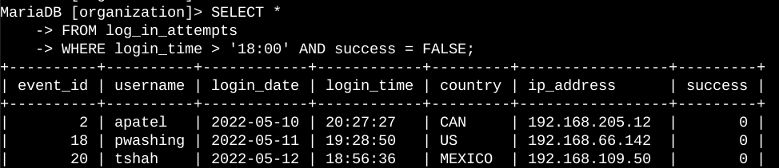

This query filters for failed login attempts that occurred after 18:00. I used a WHERE clause with AND operator to filter my results to output only login attempts occurred after 18:00 and were unsuccessful.

## Retrieve login attempts on specific dates

A suspicious event occurred on 2022-05-09. It is necessary to conduct an investigation into login activities that happened on that day or on the day before.

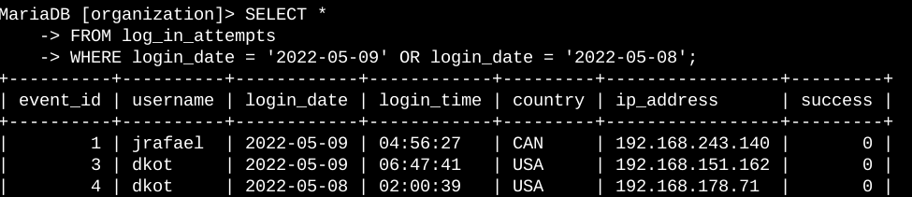

This query returns all login attempts that occurred on 2022-05-09 or 2022-05-08. I used a WHERE clause with OR operator to filter results to output only login attempts that occurred on either days.

## Retrieve login attempts outside of Mexico

We believe there is an issue with the login attempts that occurred outside of Mexico.

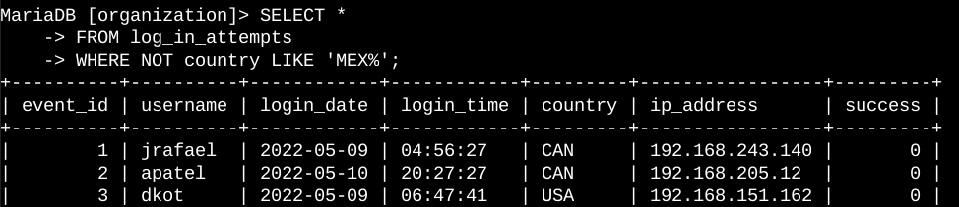

This query returns all login attempts that occurred in countries other than Mexic.

## Retrieve employees in Marketing

We want to update the computers for certain employees in the Marketing department. To update, we need to get information on which employee machines to update first.

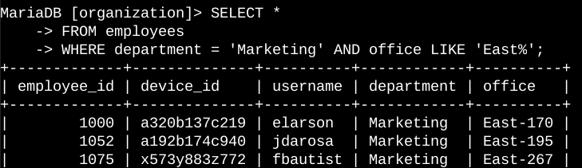

This query returns all employees in the Marketing department in the East building. I used WHERE with AND to filter for employees who work in the Marketing and in the East building. Like clause with “East%” match employees in the East building.

## Retrieve employees in Finance or Sales

The machines for employees in the Finance and Sales departments also need to be updated, so I need to get information on employees only from these two departments.

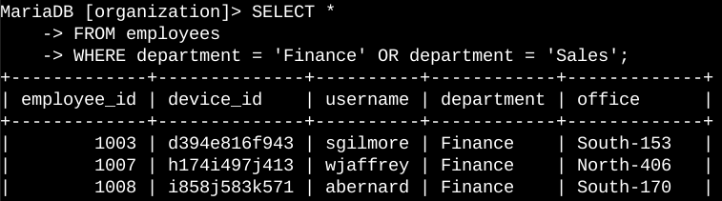

This query returns all employees in the two departments using WHERE with OR to filter for employees who are in the Finance or Sales departments.

## Retrieve all employees not in IT

We needs to make one more security update on employees who are not in the information technology department. To make it, I need to get information on these employees first.

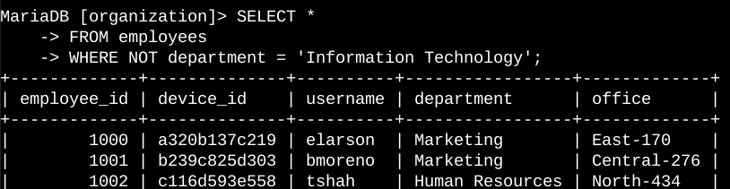

The query returns all employees not in the information technology department using by WHERE and NOT to filter for employees not in this depertment.

## Summary

I used filters to SQL queries to get specific information on login attempts and employee machines. I utilized two different tables, and the AND, OR, NOT operators. I also used LIKE and the percentage sign (%) wildcard to filter for patterns.